Game Design Document

Fill up the Following document

1. Write the title of your project.

MARIO **2.O**

1. What is the goal of the game?

THE GOAL OF THE GAME IS TO CROSS THE HURDELE COMMMING IN BETVINE MARIO AND THE CASTLE AND BRING HIS FRIEND BACK

TO HIS HOME.

1. Write a brief story of your game?

MARIO WILL FOR THE CASTLE

AND HE WILL FACE SOME PROBLEM

MONSTER AND THE POLE WIL TRY

TO STOP HIM BUT HE HAS TO COLLECT

ALL THE GOLD COINS AND GO TO THE

CASTLE AND TAKE HIS FRIEND BACK

TO HIS HOME HE HAS ONLY 4 LIFE

1. Which are the playing characters of this game?

* Playing characters are the ones which respond to the user based on the input from the user
* Cars, monkeys, dinos, wizards etc, are the playing characters in the game.

|  |  |  |
| --- | --- | --- |
| Number | Character Name | What can this character do? |
| 1 | MARIO | HE CAN JUMP RUN |
| 2 | MONSTER | HE CAN EAT THE MARIO |
| 3 | FRIEND | MARIO WILL TAKE HIS FRIEND TO HIS HOME |
| 4 |  |  |
| 5 |  |  |
| 6 |  |  |
| 7 |  |  |
| 8 |  |  |

1. Which are the Non Playing Characters of this game?

* Non Playing characters are the ones which don't ha `
* ve an action or a behaviour when the user interacts with the game.
* Hurdles, stones, bananas, coins, etc are non playing characters in the game.

|  |  |  |
| --- | --- | --- |
| Number | Character Name | What can this character do? |
| 1 | POLE | IT WILL SP MARIO |
| 2 | GOLD COIN | MARIO WILL COLLECT THE COIN AND HIS SCORE WILL BE ADDED BY 5 |
| 3 | LIFE (4) | THIS WILL HELP MARIO TO REVIVE HIMSELF AT THE SAME PLACE |
| 4 | CASTLE | IN THE CASTLE MARIO’S FRIEND IS  THERE |
| 5 | GROUND |  |
| 6 | CLOUD |  |
| 7 | SCORE | SPEED WILL INCREASE |
| 8 | HOME | MARIO LIVES HEAR |

Draw your imagination of this game. What does this game look like?

* Draw the game either on your computer or on paper,
* Add images of scenes of the game to show each of the playing and non-playing characters at least once.

1.

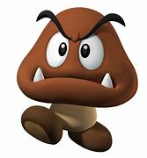

2.



3.



4.

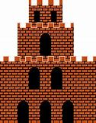

5.



6.



7.



8.



9.

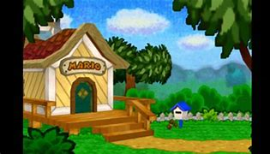

10.



11.



12.



How do you plan to make your game engaging?

MARIO HAS TO REACH THE CASTLE AND BRING HIS FRIEND BACK

TO HIS HOME